Twenty-Something Simulation Project

Name: _______________________________

Roommate: ___________________________

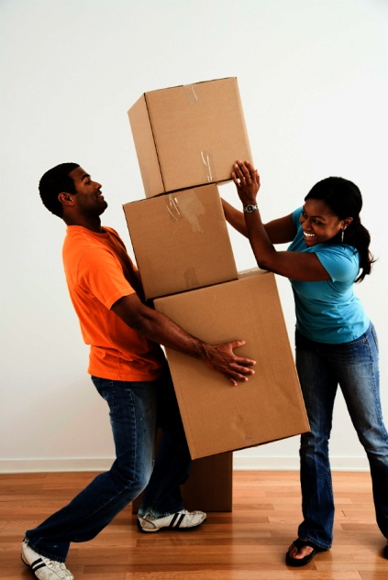 

You are twenty-something and it is time to move out of your parent’s home. No more raiding the endless supply of free food in the fridge while you relax in freshly washed (thanks Mom), fabric-softened clothes. Gone is the Wi-Fi you don’t pay for, the vacuum you’ve never used, and the bed you spend entirely too much time in. Nope, those days are over. It’s time to move out.

You work 40 hours per week and your wage is **$20 per hour gross income\***. You will be required to calculate your net income and hypothetical rental accommodation, buy a car, food, clothing, etc. The purpose of this project is to help you learn how to budget and manage financial resources effectively. You may choose to live with a (1) roommate and share rent, but you must each complete and hand in a separate booklet with a separate budget. Good luck (and get out)!!

*<https://ca.indeed.com/career-advice/pay-salary/average-canadian-salary-by-age>

<https://ca.talent.com/tax-calculator?salary=20.00&from=hour&region=Alberta>

Due: **­­­­­­­­­­­­­­­­­­­­___________________**

**My Personal Profile – Age Twenty-Something**

1. I will move out of my parents’ home when I am ______ years old.
2. My occupation or job at that time will be ___________________.
3. I will be taking home $ _______________ each month (based on your career portfolio research).
4. I plan to go to post secondary school: Definitely Maybe Later No
5. I will be married sometime in my twenties: YES NO Maybe
6. How many children will I have by the time I am 30? ___________
7. I will be driving a _______________________________________
8. I plan to buy a home sometime in my twenties YES NO
9. My home or living accommodations will be described as:
10. I will be living in/near what town or city? __________________
11. Other things I will own are:

a.

b.

c.

1. My major accomplishments in my twenties will be:

a.

b.

c.

1. I will take a yearly vacation. YES NO
2. Some of my vacations will be:

a.

b.

c.

***“Life is what happens while you’re making other plans.”*** John Lennon

**Pay Cheque Definitions**

|  |  |
| --- | --- |
| Gross Income  (Pay/Earnings) |  |
| Net Income  (Pay/Earnings) |  |
| Canada Pension Plan (CPP) |  |
| Employment Insurance (EI) |  |
| Income Tax |  |
| LTD (Long Term Disability) |  |
| Union Dues |  |
| Bonds |  |
| Advance Earnings |  |
| Overtime Earnings |  |

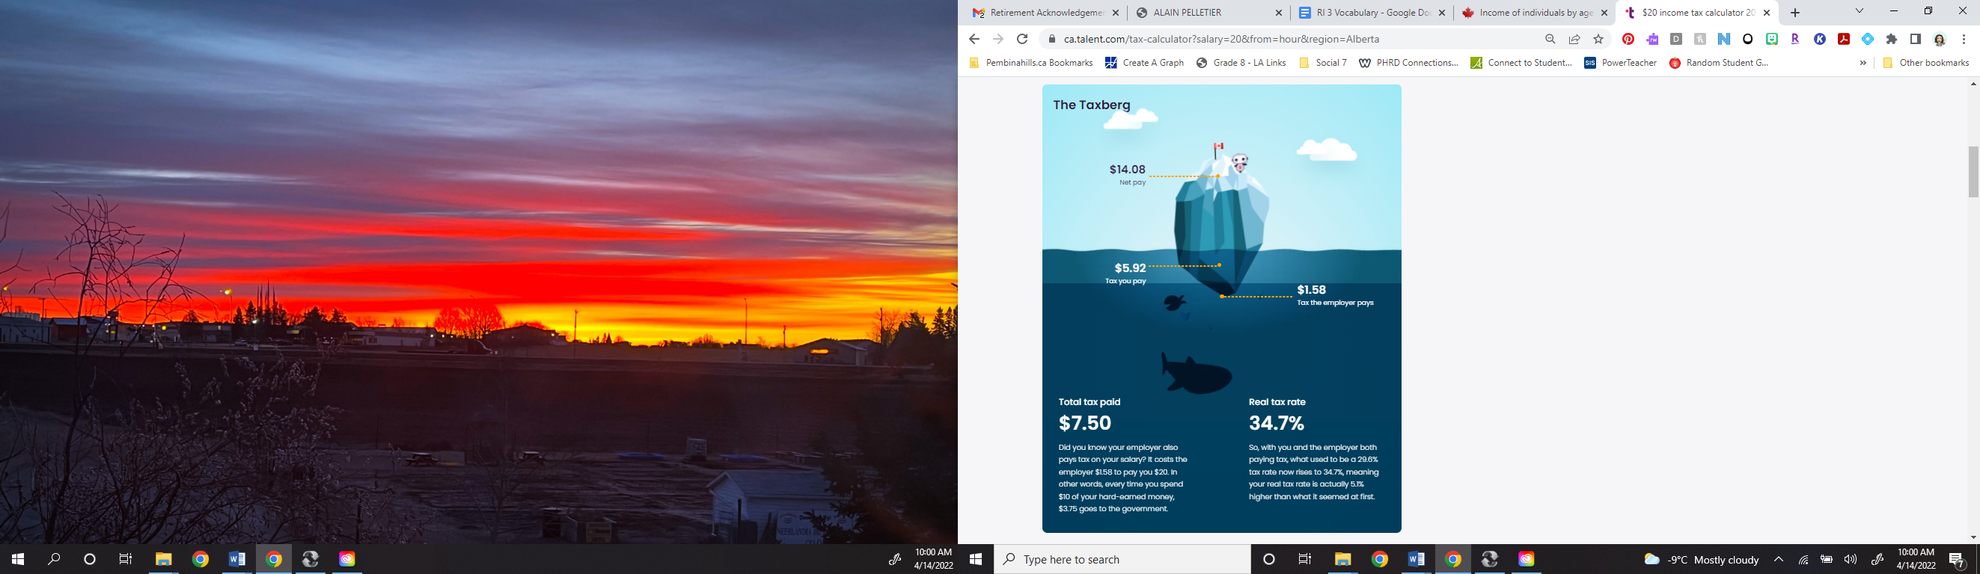 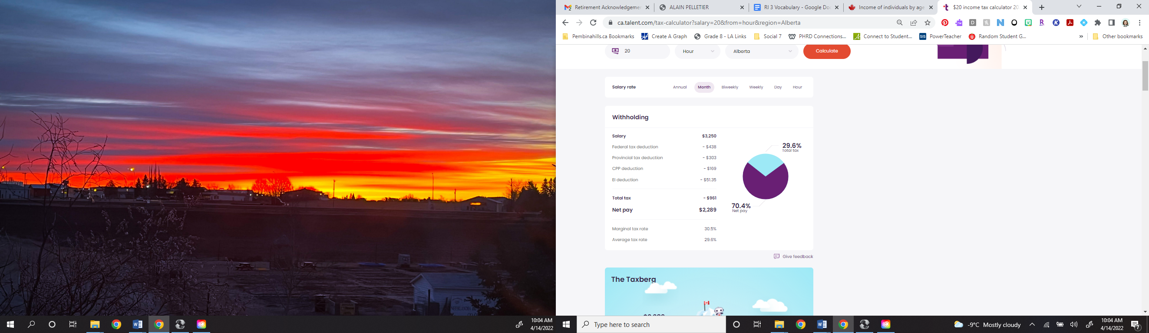

If you make $20/hour, you will make $ ______________________________ gross income/month.

Federal Income Tax Deduction $ ___________________________

Provincial Income Tax Deduction $ ___________________________

CPP – Canada Pension Plan Deduction $ ______________________

Employment Insurance Deduction $ _________________________

Income Tax + CPP + EI = Pay Cheque Deductions $ ____________________

**Gross Income $ _________ - Pay Cheque Deductions $ ___________ = Net Income $ ______________**

**Income Summary**

If you make $39,000 a year living in the region of Alberta, Canada, you will be taxed $11,537. That means that your net pay will be $27,463 per year, or $2,289 per month. Your average tax rate is 29.6% and your marginal tax rate is 30.5%. This marginal tax rate means that your immediate additional income will be taxed at this rate. For instance, an increase of $100 in your salary will be taxed $30.46, hence, your net pay will only increase by $69.54.

**Bonus Example**

A **$1,000** bonus will generate an extra **$695** of net incomes. A **$5,000** bonus will generate an extra **$3,477** of net incomes.

<https://ca.talent.com/tax-calculator?salary=20&from=hour&region=Alberta>

**To Have A ROOMMATE....OR NOT**

Determine the advantages & disadvantages of living on your own or having a roommate. For the purpose of this project, **you may only choose one roommate**.

|  |  |  |
| --- | --- | --- |
|  | **Advantages (4)** | **Disadvantages (4)** |
| **Live on my own** |  |  |
| **Live with a Roommate**  My decision is to:  I believe this is the best choice for me because:  What characteristics would be essential in a roommate? Rank your top 5 (1 = highest).  __ Trustworthy __ Respectful __ Cooperative __ Friendly __ Patient  __ Compatible __ Helpful __ Non-smoker __ Smoker __ Studious  __ Clean __ Thoughtful __ Quiet __ Party-er __ Stable |  |  |
|  |  |  |

**ACCOMMODATION OPTIONS**

|  |  |  |  |
| --- | --- | --- | --- |
| Type of Rental Accommodation | Advantages (2) | Disadvantages (2) | Rental Costs |
| Townhouse or Duplex  C:\Documents and Settings\Rebecca Carr\Local Settings\Temporary Internet Files\Content.IE5\M3N0EUAK\MC900282320[1].wmf |  |  |  |
| Apartment or Condo |  |  |  |
| Single Detached House  C:\Program Files\Microsoft Office\MEDIA\CAGCAT10\j0185604.wmf |  |  |  |

**Decisions For Consumers**

For each of the following situations, decide which kind of housing would be best. *Give reasons for your decisions.*

Retired couple with no children who don’t want to cut grass or do maintenance.

Middle aged couple with two small children, who desire room for their children and friends to visit.

A young couple with a small child.

Young, single person, who travels frequently for work.

What type of home or apartment do you picture yourself living in when you decide to move out?

__________________________________________________________________________

__________________________________________________________________________

__________________________________________________________________________

__________________________________________________________________________

**For the purposes of this simulation, you will consider rental properties only**. Find a place to rent by looking in the “For Rent” section of the newspaper or rental guide, or on an online site, such as [www.kijiji.ca](http://www.kijiji.ca) and locate an ad for a suitable apartment, townhouse or house. Call to find out the monthly rental charge without being committed to a long-term lease agreement. Ensure you know what, if any, utilities are covered in your rent. **Paste or tape the ad in the following space or staple to the back of your booklet**.

**OTHER RENTAL EXPENSES**

*Monthly cost of renting house/apartment: $*

**Tenant Insurance**

When you rent a home or apartment you must also have tenant insurance in case of fire, theft, flooding or natural disaster. Your landlord will have insurance on the building, but not on your personal possessions. On the following chart, find the cost per year that is closest to the replacement value of what you hope to own when you are 22-29. Beside it is an example of the yearly insurance premium you might need to pay.

|  |  |  |
| --- | --- | --- |
| **Replacement Coverage** | **Annual Premiums** | **Monthly Premium** |
| $10 000 | $92 per year | $ |
| $20 000 | $159 per year | $ |
| $30 000 | $208 per year | $ |
| $40 000 | $268 per year | $ |
| $50 000 | $304 per year | $ |
| $60 000 | $367 per year | $ |

Locate the yearly premium you might have to pay. Divide this by 12 to give you the monthly payment.

**Monthly cost of Tenant Insurance $ ____________**

**_______________________**

**Electricity**

An average two bedroom apartment in Alberta with two people living in it will cost about $100 month for electricity. A larger apartment or townhouse will cost about $150. A small 1100 square foot home with the usual appliances will cost about $180 per month for electricity. A large executive-type home with many appliances, a hot tub, and air conditioning may cost over $200 per month.

**Monthly cost of Electricity $ ____________**

**_______________________**

**Telephone**

If you are going to have a landline, what services will you need with it? Voice mail, call waiting, caller ID, call answer, call forward, 3-way calling – cost about $1.95 – $7.95 each or $20 for a package. Long distance charges are also extra, about $20 - $25 a month for unlimited North America calling.

* Shaw charges $60 for a phone with all the extras, and $40 for a basic phone line.
* Telus charges $20 for a basic line and $40 for the basic line + extra features.

Cell phones costs vary. Bring Your Own Device (BYOD) and it’s about $25 per month for 100 minutes phone time and unlimited weekend and evenings + unlimited texts, but up to $110 for unlimited nationwide calling. If you need the latest iPhone, it’s currently $40/month or pay $515-$1200 upfront and then rent it for $20 a month plus you pay $75 (20 GB of data) -$125 (50 GB)/month for the phone plan!

* **Minimum $25/month BYOD – maximum $165/month for the latest, greatest mobile phone.**

**Determine if you require a land line and a cell phone, or if one or the other will suffice.**

|  |  |  |  |
| --- | --- | --- | --- |
| Landline | | Cellphone | |
| Basic Rent | $ | Type of cellphone |  |
| Extra Services |  | Calling |  |
| Long Distance |  | Data |  |
| Other |  | Other |  |

*landlines can be shared with roommate while cellphones cannot.

**Monthly cost of Telephone(s) $ ____________**

**_______________________**

**Cable TV Or Streaming Services (optional)**

In Alberta, Cable TV costs $95 for 114+ channels per month on Shaw

Netflix costs $14.99 (standard 1 device) - $20.99 (premium multiple devices) per month.

Disney+ costs $9 per month or $90/year.

Crave + HBO is $19.98/month

**Monthly cost of Cable Television $ ____________**

**_______________________**

**Internet Access (optional)**

Having internet access is very desirable if your income can afford it. Costs are approximately as follows:

* High speed through Telus, PureFibre Internet 150/150 $90/month
* PureFibre Gigabit Internet through Telus is $99/month for the first 24 months
* PureFibre 1.5 Gigabit Internet through Telus is $165/month
* Shaw High Speed Cable connection: $100-165/month depending on speed, with unlimited usage

**Monthly cost of Internet $ ____________**

**_______________________**

For some ideas of some average costs in Edmonton:

**Utilities:** Natural gas, water and sewage expenses are usually included in the rent unless the rental home has an outside entrance (house, townhouse or duplex), in which case they are not usually included.

**Carbon Tax and You**: <https://www.alberta.ca/climate-carbon-pricing.aspx> - *as of 2017, the Carbon Tax in Alberta will increase natural gas, gas for vehicles and thus other costs, like groceries, by $340 - $645/year. Some people are eligible for rebates, but others won’t be.*

**Natural Gas**

It is hard to estimate utilities because the vary so much depending on different circumstances. Here are some very rough guidelines of how much they might cost in Alberta.

* Average (1200 sq. ft) house - $140 per month
* Large new home (1800 sq. ft) - $200 per month
* Larger old home with heated garage - $300 per month

**Monthly cost of Natural Gas $ ____________**

**_______________________**

**Water and Sewage**



For a small home, water and sewer costs approximately $90.80 per month. For a large home, $130.

**Monthly cost of Water and Sewage $ ____________**

**_______________________**

**ADDING IT ALL UP. . . . .**

|  |  |  |
| --- | --- | --- |
| Monthly Cost | Total | Divide by 2 if you have a roommate |
| Monthly cost of renting the home/apartment | $ | $ |
| Tenant Insurance (may share expense) | $ | $ |
| Electricity | $ | $ |
| Telephone (only a house phone can be shared) | $ | $ |
| Cable TV | $ | $ |
| Internet Access | $ | $ |
| Natural Gas | $ | $ |
| Water and Sewage | $ | $ |
| TOTAL | $ | $ |

**Total Monthly Cost of Renting Home/Apartment $ ____________**

**_______________________**

Compare your choice with your roommate’s choice and decide based on your incomes and the housing quality. You should not spend more than 35% of your net income on rent and utilities. Describe your choice below:

Place you will live: ­­­­___­­­­­­­­­­­­­­­­_________________________________________________________

Why did you choose this place to live? Does your roommate agree? How does this choice reflect your values?

**Moving-In Expenses**

As well as the monthly expenses, there are **one-time** moving-in expenses to consider.

|  |  |
| --- | --- |
| **Security/Damage Deposit** (usually same as rent) | $ |
| **Hook-up costs** |  |
| Phone | $45 (Cell phone connection fee) $55 |
| Other utilities (Heat, Power, etc.) | $50 |
| Water | $30 |
| **Deposits –** max. of 30% of your estimated yearly total per utility |  |
| Natural Gas (Heat) | $500 |
| Power (Electricity) | $360+ |
| Water | $100 |
|  |  |
| Purchase of Cell/Landline Telephones ($50 per phone up to $1200 if you are BYOD) | $ |
|  |  |
| New furniture/appliances ($500-5000) | $ |
| Moving Costs ($100 for pop, pizza & gas - $3000 for a moving company ) | $ |
| **TOTAL** | $ |

**Total Cost of Moving In $ ____________**

**_______________________**

**\*Do the remaining questions separate from your roommate\***

**TRANSPORTATION**

Tired of cruising in your mom’s mini-van? So are your friends. Time to buy your own car. You have a budget of $4000-$6500. You may not buy anything less than $3500 or more than $6500, and it must have less than 200,000 kms at the time of purchase. Even if you already have a car, too bad – you must purchase something else. It is recommended that your vehicle loans and expenses should not exceed 20% of your net income.

**Include the ad with your assignment.**

How does this vehicle reflect your values?

­­

Assume you have saved enough to make a 10% down payment and have to borrow the rest of the money.

|  |  |
| --- | --- |
| Total Price of Vehicle | $ |
| Subtract Down Payment (10% of total) | $ |
| Total Loan Amount | $ |

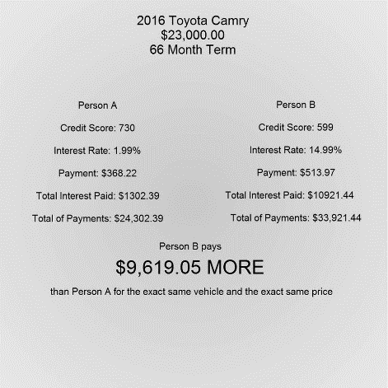Use the following table to find the monthly payments, if you finance for 48 months. If the amount of your loan is between the table amounts you will have to estimate the monthly payment. Or you can try this website: https://www.td.com/ca/en/personal-banking/products/borrowing/car-loan-calculator.

|  |  |
| --- | --- |
| **Loan Amount** | **Monthly Payment @ 8%** |
| $3000 | $73 |
| $3500 | $85 |
| $4000 | $97 |
| $5000 | $122 |
| $7000 | $171 |
| $8000 | $195 |
| $10000 | $244 |
| $12000 | $313 |
| $15000 | $365 |
| $18000 | $444 |
| $20000 | $487 |
| $25000 | $609 |
| $30000 | $731 |
| $35000 | $852 |

**Total Monthly Cost of Vehicle Loans $ ____________**

**_______________________**

**TRANSPORTATION OPERATING COSTS**

What about operating costs? Calculate how many kilometres you might drive in a week when you move. Include driving to work, shopping, recreation, visiting, etc. Allow on average 100 km for living within 15 km of work for a week. Multiply this by 4 to get the number of km for month. The average Alberta driver drives 15 200 km/year or 1267 km/month.

The average cost of an average car is approximately $0.45 per kilometre. This covers fuel, maintenance, tires, insurance, license, registration and depreciation. To calculate your monthly driving costs, multiply the number of kilometres driven per month by $0.45. If you have higher insurance costs or an expensive car, you should multiply the kilometres by $0.55.

______________________ _________ ____________________

Kilometres driven per month x $0.45 or $0.55 Monthly Operating Cost

Now calculate the total monthly cost:

|  |  |
| --- | --- |
| Monthly Loan Payments | $ |
| Monthly Operating Cost | $ |
| Total | $ |

**Total Transportation Expenses $ ____________**

**_______________________**

Compare this to the cost of public transportation. A city bus pass is about $97.00 per month.

**TRANSPORTATION DECISIONS**

According to your income, determine the method of transportation you will be using. Would you use your own car or public transportation? Why?

If you choose not to buy a vehicle, what method of transportation will you use?

**SHOPPING FOR FOOD**

The following is a shopping list to prepare three meals a day for one week*. Research the price of these food items in your local grocery store or online flyers. **You may replace unwanted items with an item from the same food group, but you must replace them with something similar.**

|  |  |  |  |
| --- | --- | --- | --- |
| **Item** | **Size** | **Brand** | **Price** |
| Spaghetti |  |  |  |
| Spaghetti sauce |  |  |  |
| Potatoes |  |  |  |
| Eggs |  |  |  |
| Milk |  |  |  |
| Bread |  |  |  |
| Butter/Margarine |  |  |  |
| Orange Juice |  |  |  |
| Chicken/Tofu |  |  |  |
| Hamburger/Veggie Ground |  |  |  |
| Pork chops/Mixed nuts |  |  |  |
| Sandwich meat |  |  |  |
| Apples |  |  |  |
| Oranges |  |  |  |
| Bananas |  |  |  |
| Lettuce/salad |  |  |  |
| Instant dinners |  |  |  |
| Frozen vegetables |  |  |  |
| Pudding or other dessert option |  |  |  |
| Canned tuna or other protein |  |  |  |
| Cheese |  |  |  |
| Coffee or Tea |  |  |  |
| Total food expenses for one week | | |  |
| Total food expenses for one month (Weekly multiplied by 4)* | | |  |

*This is not a shared cost with your roommate

**CLOTHING PURCHASES**

(Complete separately from roommate)

When calculating the cost of clothing for yourself, consider the type of work you plan to be doing and how important clothing will be to you. Consider how many of each item of clothing you will purchase in a year and multiply this by the cost per item. Some items you may not wear, some you may already have (but clothing does suffer from wear and tear, going out of style, not fitting, etc.).

|  |  |  |  |
| --- | --- | --- | --- |
| **Item** | **Number** | **Average Cost** | **Total** |
| Shirts |  | $ | $ |
| Pants/Slacks |  | $ | $ |
| Coats/Jackets |  | $ | $ |
| Swimsuits |  | $ | $ |
| Shorts |  | $ | $ |
| T-shirts/Tops |  | $ | $ |
| Suits |  | $ | $ |
| Pyjamas |  | $ | $ |
| Underwear/Socks/Ties |  | $ | $ |
| Shoes |  | $ | $ |
| Sports Clothing |  | $ | $ |
| Total for one year | | | $ |
| **Divided by 12 for monthly cost** | | | **$** |

**Total Monthly Cost for Clothing $ ____________**

**_______________________**

**Ways to Save on Clothing**

1. Learn to make minor alterations, e.g. hemming, to get longer wear from an item
2. Launder items promptly to avoid stains ruining them, and wash them inside out to prevent pilling & fading.
3. Wash with cold or cool water (fabric lasts longer & saves on water costs too!)
4. Use the right amount of detergent - most people use too much – 2 tsps. works for most loads!
5. At the laundromat, use a warm dryer to decrease drying time (and thus cost)
6. Polish your shoes – they’ll look new again (and you might not need to buy any)
7. Buy second hand or on consignment - you never know what treasure you may find!
8. Exchange items with friends or family - lets you have more for less!
9. Take items you no longer wear to the consignment store
10. Only buy items that fit now and that you really love
11. If you like name brands, buy one or two key pieces each season and then save on what you buy to wear with them or wait for them to go on sale!
12. Learn to coordinate your wardrobe so that you have more choices to mix & match
13. Shopping with cash helps you stay within your budget

**HEALTH CARE AND HYGIENE**

One visit to the dentist including check-up, x-rays and teeth cleaning can cost $665 or more. If you are on a monthly prescription, ex: insulin, don’t forget to add this amount in. Skipping out on dental checkups can quickly lead to other problems. Eye exams are approximately $85-125 per visit and are recommended every 2 years. Glasses can cost $250+ per pair and contacts are approximately $85 for 6 mos. For annual expenses, divide by 12 to determine monthly totals. You may have benefits through your workplace, but if you don’t, you could be looking at paying $58.97 (basic coverage, more co-pay) - $132.91 (better coverage, less co-pay)/month for Alberta Blue Cross* or $118/month for 2 or more people in a family. More info on Blue Cross here: <https://www.ab.bluecross.ca/individuals-families/index.php>

|  |  |  |
| --- | --- | --- |
|  | **Annual Total** | **Monthly Total** |
| Alberta Health Care | Free as of January 2008 | Free |
| *Private Healthcare like Blue Cross – still may require co-paying part of expense | $ | $ |
| Dental | $ | $ |
| Medications | $ | $ |
| Toiletries, make-up, haircuts, dry cleaning | $ | $ |
| Optical | $ | $ |
| Toilet Paper, tissues, etc. | $ | $ |
| **Total Cost Per Month** | | **$** |

**Total Health Care & Hygiene Expenses $ ____________**

**_______________________**

**RECREATION AND ENTERTAINMENT**

Recreation is a personal item which reflects personal values. It is important to budget for all non-work activities. In this section, plan for such things as concerts, athletic or social clubs, membership, skiing, travelling, hobbies, buying a boat or other recreational equipment, music lessons, movies, videos, parties, etc.

|  |  |  |
| --- | --- | --- |
|  | **Annual Cost** | **Monthly Total** |
| Movies, DVDs, concerts, etc. | $ | $ |
| Restaurants, eating out | $ | $ |
| Memberships (divide annual cost by 12) | $ | $ |
| Magazines, newspaper subscriptions | $ | $ |
| Travel (divide annual cost by 12) | $ | $ |
| Hobbies | $ | $ |
| Parties, social activities | $ | $ |
| Pets | $ | $ |
| Sports equipment | $ | $ |
| **Total** | | **$** |

**Total Recreation & Entertainment Expenses $ ____________**

**_______________________**

How does this reflect your values?

**HOUSEHOLD MAINTENANCE AND FURNISHINGS**

That old flower print couch from your parent’s basement that smells a little funky? Love it. Old towels that your grandma is giving you for free? Yes, please! You’re moving out, and this is no time to be picky. However, even though these items might be free, living on your own does come with routine maintenance and repair costs. Light bulbs don’t buy themselves.

Avg. Cost of Household Maintenance and Repairs (monthly):

Apartment: $65.00

Duplex or townhouse: $80.00

Single detached house: $95.00

**Total Monthly Cost Of Household Maintenance $ ____________**

**_______________________**

**SAVINGS**

When you move out, what do you think you will be saving money for? List at least six or seven specific items:

1.

2.

3.

4.

5.

6.

7.

8.

9.

Remember you should always save money for emergencies, such as a car accident, death of a family member, loss of a job, medical bills, a different lifestyle, etc**. It is recommended that you save 10% of your income, prior to spending any of your money.** (For this assignment, that would be $228.90)

How much money would you like to save per year? Divide by 12 to determine monthly savings.

**Total Monthly Savings $ ____________**

**_______________________**

**CHARITIES AND GIFTS**

How much would you donate per month to your church, synagogue, mosque and charities? What about gifts for your family? How much do you spend on birthday gifts and Christmas presents? Divide a yearly estimate by 12 to find a monthly amount.

**Total Monthly Cost of Charities and Gifts $ ____________**

**_______________________**

**OTHER INSURANCE**

Tenant and vehicle insurance are included with previous calculations, you may have opted for Health Benefit Coverage, but now is the time to look at Life Insurance & Disability Insurance. A $100,000 life insurance policy can be yours for less than the price of 3 Starbucks trips a month (around $13/month), Disability insurance policies start at $10.50 per month for injury-only coverage with a $500/month tax-free payout.

**Total Monthly Cost of Other Insurance $ ____________**

**_______________________**

**MISCELLANEOUS**

What else do you spend your money on each month?

|  |  |
| --- | --- |
| Smoking/Alcohol | $ |
| Education | $ |
| Other (magazines, cleaning supplies, tools, repairs, etc.) | $ |
| **Total** | **$** |

**Total Monthly Cost of Miscellaneous $ ____________**

**_______________________**

**SUMMARY OF TOTAL MONTHLY EXPENSES**

Using the preceding sheets, add up the total monthly costs for you to live the way you would like:

|  |  |  |
| --- | --- | --- |
| Housing | Page 10 | $ |
| Transportation | Page 13 | $ |
| Food | Page 14 | $ |
| Clothing | Page 15 | $ |
| Health Care and Hygiene | Page 16 | $ |
| Recreation and Entertainment | Page 17 | $ |
| Household Maintenance and Furnishings | Page 18 | $ |
| Savings | Page 18 | $ |
| Charities and Gifts | Page 19 | $ |
| Insurance | Page 19 | $ |
| Miscellaneous | Page 19 | $ |
| **Total Monthly Expenses** | | **$** |
| **Net Monthly Income\*** | | **$2289.00** |
| **Difference** | | **$** |

*from the 4th page – DO NOT MAKE UP YOUR OWN INCOME

If the difference is positive, you can afford your lifestyle. If negative, you will need to cut back.

Can you afford your lifestyle? YES NO

If no, what can you change in order to have a balanced budget?

If yes, what will you do with the excess?



**NOW WHAT DO I DO?**

|  |  |  |
| --- | --- | --- |
| **Financial Crisis** (Get from Teacher) | | |
| **The Alternatives**  Ex. Borrow money from my Grandma | **Advantages**  Ex. My grandma doesn’t charge interest, she’ll give me the money | **Disadvantages**  Ex. My grandma will now expect me to shovel her walk, visit every Sunday and be at her beck & call. |
|  |  |  |
|  |  |  |
|  |  |  |
| The Solution: | | |
| This is the best solution for me because: | | |
| The steps in my plan of action are: | | |

**Leaving the Nest**

Pages 34 – 35 (attached from Venturing Out)

What is “number one on the list” of things to do before moving out?

______________________________________________________________________________­­­­­­­­­­­­­­­­­­­­­­­

______________________________________________________________________________

______________________________________________________________________________­­­­­­­­­­­­­­­­­­­­­­­

What is the “touchiest, most volatile area of renterdom?”

______________________________________________________________________________­­­­­­­­­­­­­­­­­­­­­­­

______________________________________________________________________________

______________________________________________________________________________

What is Rule 1?

______________________________________________________________________________­­­­­­­­­­­­­­­­­­­­­­­

______________________________________________________________________________

______________________________________________________________________________

What is Rule 3?

______________________________________________________________________________­­­­­­­­­­­­­­­­­­­­­­­

______________________________________________________________________________

______________________________________________________________________________

What is Rule 6?

______________________________________________________________________________­­­­­­­­­­­­­­­­­­­­­­­

______________________________________________________________________________

______________________________________________________________________________

What is Rule 7?

______________________________________________________________________________­­­­­­­­­­­­­­­­­­­­­­­

______________________________________________________________________________

______________________________________________________________________________

**Rules of The Road When Setting Up**

Pages 38 – 39 (attached from Venturing Out, Pearson Education, Inc.)

What do you need to talk to people about?

______________________________________________________________________________­­­­­­­­­­­­­­­­­­­­­­­

______________________________________________________________________________

______________________________________________________________________________­­­­­­­­­­­­­­­­­­­­­­­

What might the total cost for deposits and hook ups be?

______________________________________________________________________________­­­­­­­­­­­­­­­­­­­­­­­

______________________________________________________________________________

What are some other start-up costs you may incur?

______________________________________________________________________________­­­­­­­­­­­­­­­­­­­­­­­

______________________________________________________________________________

______________________________________________________________________________

According to the article, do you need a newspaper? Why or why not?

______________________________________________________________________________­­­­­­­­­­­­­­­­­­­­­­­

______________________________________________________________________________

Where should you never do serious grocery shopping?

______________________________________________________________________________­­­­­­­­­­­­­­­­­­­­­­­

What do you need to “look at” when it comes to banks?

______________________________________________________________________________­­­­­­­­­­­­­­­­­­­­­­­

______________________________________________________________________________

______________________________________________________________________________

What is good about living on your own?

______________________________________________________________________________­­­­­­­­­­­­­­­­­­­­­­­

____________________________________________________________________________________________________________________________________________________________­­­­­­­­­­­­­­­­­­­­­­

**Types of Insurance**

Using pages 86, (attached from LIFECHOICES - Venturing Out, Pearson Education, Inc.), define the following types of insurance:

**Property Insurance**

___________________________________________________________________________________________________________________________________________________________

________________________________________________________________________________________________________

___________________________________________________________________________________________________________________________________________________________

**Health Insurance**

___________________________________________________________________________________________________________________________________________________________

____________________________________________________________________________________________________________________________________________________________

**Travel/Cancellation Insurance**

___________________________________________________________________________________________________________________________________________________________

____________________________________________________________________________________________________________________________________________________________**Disability Insurance**

___________________________________________________________________________________________________________________________________________________________

____________________________________________________________________________________________________________________________________________________________**Life Insurance**

___________________________________________________________________________________________________________________________________________________________

____________________________________________________________________________________________________________________________________________________________**Perils**

___________________________________________________________________________________________________________________________________________________________

____________________________________________________________________________________________________________________________________________________________**Claim**

___________________________________________________________________________________________________________________________________________________________

____________________________________________________________________________________________________________________________________________________________**Policy**

___________________________________________________________________________________________________________________________________________________________

____________________________________________________________________________________________________________________________________________________________**Premium**

___________________________________________________________________________________________________________________________________________________________

____________________________________________________________________________________________________________________________________________________________**Deductible**

___________________________________________________________________________________________________________________________________________________________

____________________________________________________________________________________________________________________________________________________________

**PROJECT EVALUATION**

What did you like about the Twenty Something Simulation Project?

What do you believe could be improved about the Twenty Something Simulation Project?

What do you believe you did well in the Twenty Something Simulation Project?

What do you believe you could do better?

Did you and your partner (if you had one) work equally? If not, explain.

What have you learned?

