​Portfolio Stay On Track Page:
In order to stay on track with your portfolio, I would suggest completing requirements in the following order:
1. Complete & Print the Who Am I Surveys from the MyBlueprint Portfolio on www.myblueprint.ca – You will need to log in using the Activation Key: Barrhead and your Alberta Student Number, found on your Course Mark Inquiry/DARS.
a. To print, you will need to add the Who Am I Surveys to your portfolio (there is an add button beside the results for each survey.
b. Click on your initials in the top right hand corner of the screen when all surveys are completed. Select “Download and Share”. Add “Who Am I Results”, click on the “Download” button and Print this page for your portfolio. (See back of page)
2. Print off job information for 2 careers from the Alis website based on your findings from #1. Complete job descriptions on My Blueprint page: Career Summary Page.
3. Complete the Post Secondary Education Summary for 1 of the occupations you summarized above.
4. Complete your résumé - you can use one of the templates on my Teacher Page for CALM, if not, please ensure you are using a current resume style and keep it to 1 - 2 pages. If you're going onto a 2nd page, ensure you have your name and p. 2/2 in the header, in case the résumé gets separated. Ensure your résumé has 3 references on it, or that you include another page, in the same format as your résumé with references listed.
References should include: First & Last Name, Occupation, City & Province & Contact # and/or email.
5. Create a cover letter for a job of your choice.
You can address it to:
Bob Smyth
Manager
Dynamic Company
4521 – 45 Street
Edmonton, AB T5E 1B1
6. Collect other items pertinent to your portfolio: transcript/course mark inquiry sheet, True Colors certificate, other certificates, awards, seminars attended, hobby & interest sheet, pictures, examples of work, references, Career and Life Management Questionnaire and Dream Sheet, etc.
7. When your portfolio is completed, work on Career Summary from the back page of Portfolio Contents & Career Summary.
8. Complete your Self Evaluation and include at the front of your portfolio binder, after the rubric.
9. Include the Portfolio Rubric at the front of your portfolio binder. Your résumé should be the third item, in the protective cover.
10. Discard any unnecessary information from your portfolio, like this page.

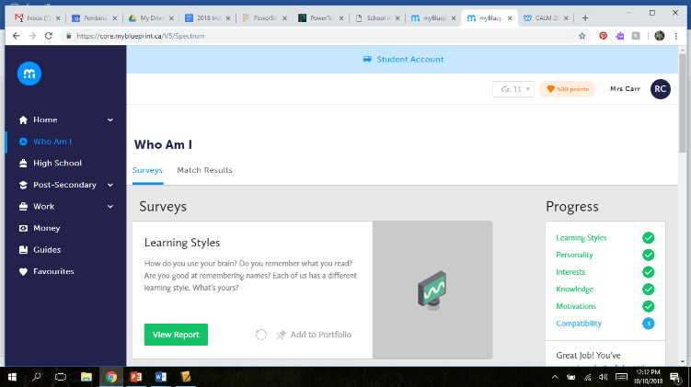
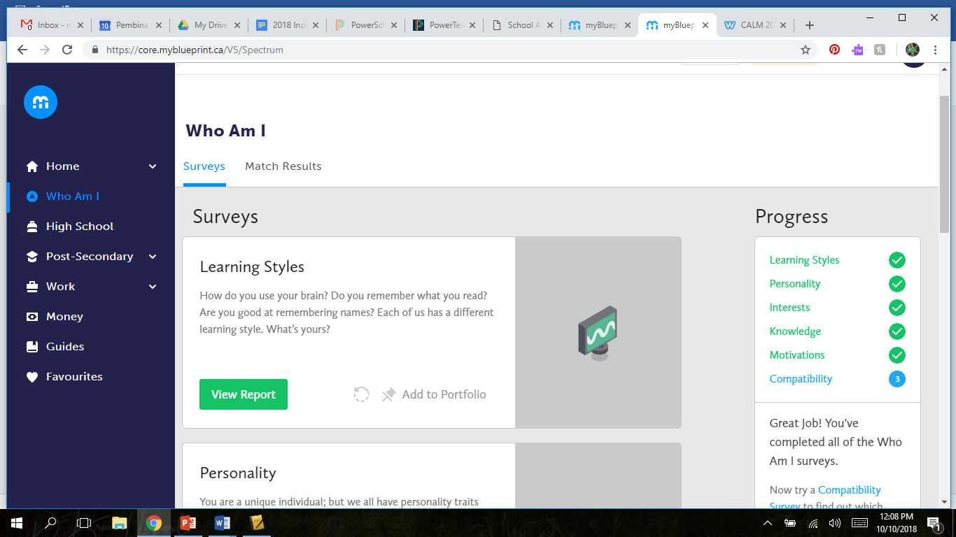
Add all of the surveys to Portfolio (create one, if you don’t have one)

When the surveys are all completed,
Select your initials in the corner

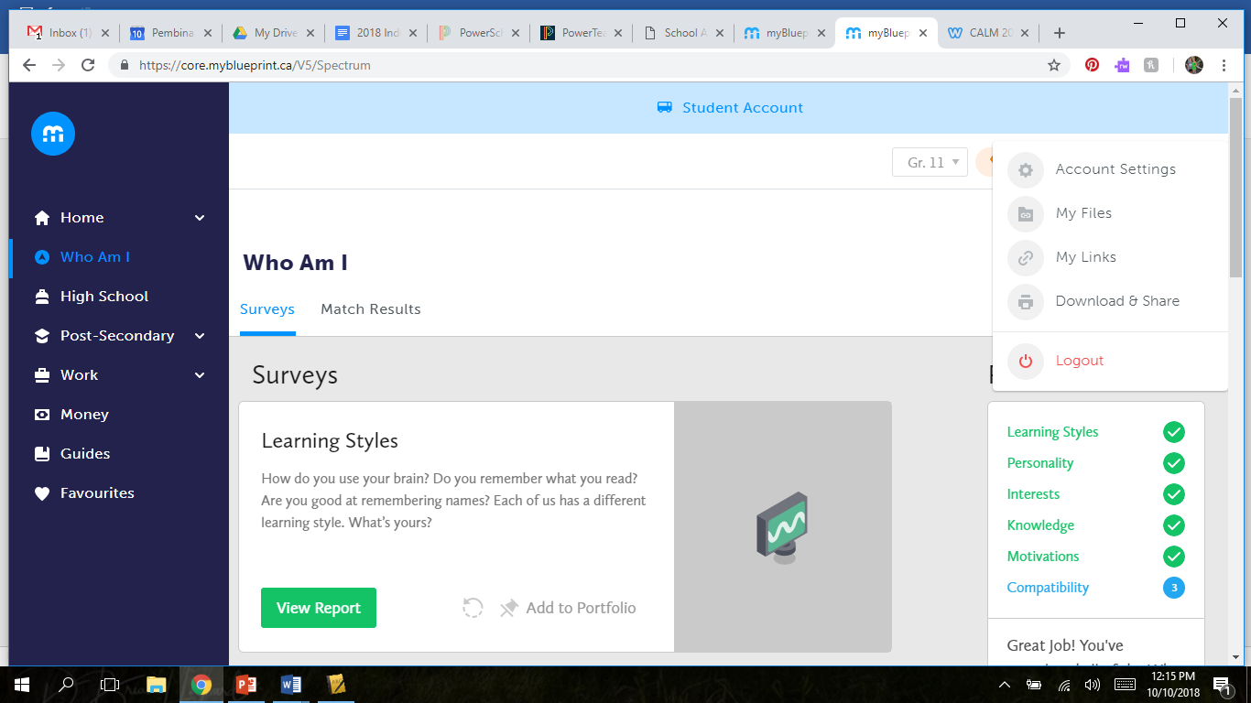
Add the “Who Am I Results”
Hit the “Download” Button
Print the results that come up and add to your Career Portfolio.
Select Download & Share
