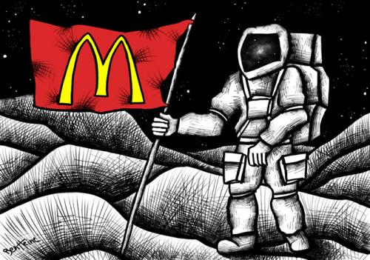
Explode a Quote/Idea
McDonald’s is a transnational corporation. They are located 120 countries across the world.
Why not the moon? It’s pretty much everywhere else!
Perhaps if we all chose locally owned/operated restaurants, McDonald’s wouldn’t have as far of a reach as it currently does. But, people tend to go with what they know.

This supports the point that if McDonald’s supports a particular thing, it is far-reaching.
For example, if McDonald’s was to suddenly stop serving greasy burgers and fries, and add more healthy options, this would have an affect across the globe, not just in North America.
If McDonald’s stops using straws or Styrofoam packaging, it could promote other fast food restaurants to stop, as well.

Around 68 million people visit McD’s every day.
How does McDonald’s play a role in globalization?
McDonald's has become an emblem of globalization, so much that the term "McDonaldization" has emerged. The Economist magazine uses the Big Mac Index, which compares the Big Mac’s cost in different world currencies, which can be used to establish the purchasing power parity (PPP) of currencies. As of July 2015, Switzerland had the world’s most expensive Big Mac, while the least expensive is in India followed by Hong Kong.
https://www.worldatlas.com/articles/countries-with-the-most-mcdonald-s-restaurant.html (accessed February 3, 2020).

Purpose:
- Explain, in detail, a relatively short quote/cartoon/idea.
Components:
- Establish context.
  - What is going on? Who is involved?
- Explain meaning.
- Explain significance.
  - Include literary techniques.
    - Irony, foreshadowing, symbolism, etc.
- Connect to other events, situations within the book
- Colour can be used for effect.
The prompts down the side of the page are as follows:
Basic
- Implies
- Suggests
- Demonstrates
- Shows
- Highlights

...PLUS...
Better
- Also
- Another
- In addition
- Furthermore
- Taking this further
- Perhaps
- Maybe

...PLUS...
Best
- This is similar to/different from
- The author might be
- Elsewhere in the text
- This links to the idea
- This supports the point

http://www.spark-ed.co.uk/spark/explode-a-quotation

